

American International University-Bangladesh (AIUB)  
**Department of Computer Science  
Faculty of Science & Technology (FST)**

**Pharmaceutical Ecommerce & Blog**

A Software Requirement Engineering Project Submitted

By

|  |  |  |  |  |
| --- | --- | --- | --- | --- |
| **Semester: Fall_22_23** | | **Section: G** | **Group Number: 07** | |
| SN | Student Name | Student ID | Contribution (CO1+CO2) | Individual Marks |
| 28 | SHAHRIAR, B.M. MAHIR | 19-40538-1 |  |  |
| 36 | BISWAS, KAWSHIK | 20-42118-1 |  |  |
| 38 | BITHI, MST. SHARMINA AKTER | 20-42935-1 |  |  |
| 39 | MARUFI, MOST. MASNAT | 20-43122-1 |  |  |
| 40 | SANI, MAHTAB ULLAH | 20-43140-1 |  |  |

The project will be Evaluated for the following Course Outcomes

|  |  |  |
| --- | --- | --- |
| **CO1:** *Apply* the principles of engineering management and economic decision to manage thesis/project as a team member/team leader. | Total Marks | |
|  | |
| **Project/Thesis Value:** Project Value is reasonable to the current market value and have promising Profitability. | [5 Marks] |  |
| **Stakeholder Perspective:** Thoughtfully consider perspectives of diverse relevant stakeholders and articulate these with great clarity, accuracy, and empathy. | [5Marks] |  |
| **Code of Ethics Consideration:** Clearly articulate relevant Code of Ethics considerations and address these in discussing approaches to resolve the  problem(s). Make linkages between ethical considerations and stakeholder interests and discuss ways to mediate dilemmas or suggest tradeoffs. | [5Marks] |  |
| **CO2:** *Evaluate* the scope of independent and life-long learning in solving complex engineering problems and change of technologies | Total Marks | |
|  | |
| **Motivation of the work:** Explore the project/thesis topic with evidence rich awareness indicating intense interest in the area. | [5Marks] |  |
| **Critical Thinking:** Understands the concepts very well and creates new knowledge | [5Marks] |  |
| **Future studies:** The scope of future studies is stated and discussed elaborately with details of how this study can be extended in future endeavored | [5Marks] |  |

Table of Contents

Revision History 4

1. Introduction 5

1.1 Purpose 5

1.2 Document Conventions 5

1.3 Intended Audience and Reading Suggestions 6

1.4 References 6

2. Overall Description 7

2.1 Product Perspective 7

2.2 Product Functions 7

2.3 User Classes and Characteristics 10

2.4 Operating Environment 10

2.5 Design and Implementation Constraints 11

2.6 User Documentation 12

3. System Requirements 12

3.1 User Scenario 12

3.2 System Features 14

3.2.1 Customer Login 14

3.2.2 Customer Sign Up 15

3.2.3 Newsletter Subscribe 15

3.2.4 Browse Shop 15

3.2.5 View Single Product 16

3.2.6 Leave Review 16

3.2.7 Leave Rating 16

3.2.8 Add Any Product to Cart 16

3.2.9 Add Unrestricted Product to Cart 17

3.2.10 Remove Product from Cart 17

3.2.11 View Cart 17

3.2.12 Edit Cart 18

3.2.13 Apply Coupon Codes 18

3.2.14 Apply Reference Codes 18

3.2.15 Confirm Order 19

3.2.16 Browse Blog 19

3.2.17 View Single Blog 19

3.2.18 Owner Login 20

3.2.19 Add Product 20

3.2.20 View All Products 20

3.2.21 View Single Product 20

3.2.22 Modify Product 21

3.2.23 Remove Product 21

3.2.24 Add Blog 21

3.2.25 View All Blogs 21

3.2.26 View Single Blog 22

3.2.27 Modify Blog 22

3.2.28 Remove Blog 22

3.2.29 View Single Site Settings 23

3.2.30 View All Site Settings 23

3.2.31 Modify Site Settings 23

3.2.32 Remove Site Settings 23

3.2.33 View Orders 24

3.2.34 Accept Orders 24

3.2.35 Cancel Orders 24

3.2.36 Delete Orders 24

3.2.37 Generate Reference Code 25

3.2.38 Claim Commission 25

3.2.39 Restrict Products 25

3.3 Non-Functional/Quality Requirements 26

3.4 Project Requirements 27

3.5 Data Dictionary 27

4. Interface Requirements 28

4.1 Use Case Diagram 28

4.2 Activity Diagram 29

4.3 Class Diagram 30

4.4 Entity Relationship Diagram 31

4.5 UI Design Specification 31

# Revision History

|  |  |  |  |
| --- | --- | --- | --- |
| **Name** | **Date** | **Reason for Changes** | **Version** |
| Group 07 | 08/10/2022 | Redundancy in intended audience and reading suggestion, Unrelated information in operating environment, incomplete identification of user classes, missing non-functional requirements and error in use case diagram | 1.0 |
| Group 07 | 09/10/2022 | Updated information in Design and Implementation Constraints and adding activity diagram | 2.0 |
| Group 07 | 10/10/2022 | Updated Class diagram and UI | 3.0 |

# Introduction

## Purpose

The purpose of this project is to provide a detailed description of an e-commerce system for pharmaceuticals. It describes the functions and characteristics of the system, its limitations and purposes, and the constraints of the external environment with which the system must function and respond properly. Both investors and developers of the system use this document for their understanding and endorsement.

This software system is an e-commerce system for pharmaceuticals and is designed for ordering purposes. The purpose of this system is to bring together all previous knowledge about various medicines into a single, frequently operated and updated database. Maintain records of store sales, purchases, and backorder quantities. It helps users search for medicines, prices, and retail availability.  
More specifically, the system designed will allow registered users to search for specific medicines and easily order them online. Online payment options are available to users in addition to "cash on delivery". Users can track orders with drug details. This system helps minimize time and resources. It helps patients to get medicine without going to the store.

## Document Conventions

The document is written very simply but uses a specific format to define specific identities. Bold words used in content titles. Normal words are used for hardware and software requirements for running pharmaceutical e-commerce.

This document helps provide relevant information to stakeholders, creates a good vehicle for interaction, and provides high-level information about project concepts in context. The report also provides a window for stakeholders to better understand the project. This document is intended to provide interested parties with user-friendly and accessible system information during the development of this system.

***Table 1: abbreviations used in the SRS documents.***

|  |  |
| --- | --- |
| Abbreviations | Full form |
| SRS | software requirements specification |
| SMS | Safety Management Specialist |
| BCSP | Board of Certified Safety Professionals |
| APA | American psychological Associations |
| PE | Pharmaceutical E-commers |
| SQL | Structured Query Language |

## Intended Audience and Reading Suggestions

The target audience for this document is Project Managers, Domain Experts, Developers, and Requirements Engineers. It is highly recommended that you read the paper to understand pharmaceuticals e-commerce before reading this document. Audience such as:

* Developers
* Project managers
* Marketing staff
* Users (e.g., doctors, sales representative, etc.)
* Testers
* Documentation writers

As per the document is intended for project managers, developers, testers, marketers, users, and document authors so, the document is divided into five parts. Foreword

1. Introduction
2. Overall description
3. System features
4. External interface requirements
5. Quality attribute requirements

All parts are independent of each other but reading the document in order will give the reader a better understanding of their Pharmaceutical Ecommerce system.   
The rest of this document consists of three parts. The second provides an overview of system functionality. Introduce different types of stakeholders and how they interact with the system. It also describes the environment in which the software operates, including hardware platforms, operating systems and versions, and other software components and applications that should coexist peacefully. In addition, this part also mentions system constraints and assumptions about the project. This part is very useful for users of this system. Part 3 contains detailed requirements specifications and descriptions of various system interfaces. This part is written primarily for developers, as it describes the software's features in detail in technical terms. It is also written for users as it has a use case. The final part provides a numbered list of discoverable references. These remain in the SRS for tracking to completion. It also lists open issues and things that SRS still needs to do but has not yet addressed.

## References

1.https://vator.tv/news/2022-11-28-digital-health-news-funding-round-up-in-the-prior-week-november-28-2022

2. <https://physicsworld.com/a/anthropomorphic-steev-phantom-underpins-independent-auditing-of-srs-programmes/>

3. https://www.mpa.gov.sg/singapore-registry-of-ships/crewing/manning-requirements-while-operating-your-ship

# Overall Description

## Product Perspective

Pharmaceutical Ecommerce is a system which is here with a lot of new ideas. The system is self-contained and it is not replacement of any existing system. This is a web-based system and hence will require a browser.

## Product Functions

We have identified different user classes for this product. According to the user classes user privileges are different. Product are listed below along with user classes:

From the Patient’s perspective the system is capable of doing the following functionalities-

* Login
* Sign Up
* Subscribe to Newsletter
* Browse Shop
* View Single Product
* Add Product to Cart
* Remove Product from Cart
* View Cart Page
* Edit Cart Item
* Apply Coupon Code
* payment
* Confirm Order
* Buy allowed product
* Cancel order
* Browse Blog
* View Single Blog
* Give feedback

From the Doctor’s perspective the system is capable of doing the following functionalities-

* Log in
* Sign up
* View blog
* Search blog
* View single blog
* Subscribe to Newsletter
* Browse shop
* View product
* Add to cart
* Remove from cart
* View cart
* Confirm order
* Buy all product
* Search for any product
* Order for patient
* Cancel order
* Give feedback

From the Pharmacy’s perspective the system is capable of doing the following functionalities-

* Log in
* Sign up
* Subscribe to Newsletter
* Browse shop
* View product
* Add to cart
* Remove from cart
* View cart
* Payment
* Confirm order
* Cancel order
* View blog
* Search blog
* View single blog
* Buy all product
* Search for any product
* Can buy large quantity
* Permanent discount
* View discount offer
* Use discount offer
* View stock
* Give feedback

From the Sales representative’s perspective the system is capable of doing the following functionalities-

* Sign up
* Log in
* View blog
* Search blog
* View single blog
* Browse shop
* View product
* Get commission
* View commission details
* View selling target
* Update sales details
* Give feedback

From the DGDA’s perspective the system is capable of doing the following functionalities-

* Sign up
* Log in
* View all product
* View product license
* View product details
* Verify product
* Ban product
* Give feedback

From the owner’s perspective the system is capable of doing the following functionalities-

* Login
* Release Product
* View All Products
* View Single Product
* Modify Product
* Remove Product
* Add Blog
* View All Blogs
* View Single Blog
* Edit Blog
* Delete Blog
* View All Site Settings
* View Single Site Settings
* Add Site Settings
* Modify Site Settings
* Delete Site Settings
* View Orders
* Accept Orders
* Cancel Orders
* Delete Orders
* View feedback

## User Classes and Characteristics

In this system main user classes are customers and admins or owners. So, the system will support these two user privileges. Customers are using the system to get services from the system and admins are here to serve the customers. In this system customers can also be categorized as subscribed customers and general customers. Customer classes has particular functionalities and admins has different functionalities to use. For security purpose customers are apart from some functionalities which is only under control of admins to manage the whole system. The most important user class is our subscribed customers. It is most important here to satisfy them first than other user classes.

User classes and their characteristics given below:

|  |  |
| --- | --- |
| User Classes | Characteristics |
| Patient | Patients usually want to buy products as their doctor’s suggestions. In this case they need faster delivery like in 30 minutes. |
| Doctor | Doctors want to order for patient’s as prescriptions or may be order for own. They need to access all product details, no restriction like patients. |
| Pharmacy | Pharmacy wants to order products in a huge quantity and they want to manage their stock information through this system. They also demand a discount as they are willing to order huge products. |
| Sales representative | Sales representatives want to work as a marketing person who will get commission.  According to his sales he will get commission. |
| DGDA | Directorate general of drug administration wants to check all products validity and license. The products verified by them will be allowed to display to the patients. |

## Operating Environment

AlvitaNutrition is a website and shall operate in all famous browsers, for a model we are taking Microsoft Edge, Google Chrome, Mozilla Firefox with flash Player and JavaScript.

The system is composed of multiple parts:

* The main domain (alvitanutrition.com) which will be hosted on a Cloud Virtual Private Server (VPS) for delivering the website to users.
* A CDN (Content Delivery Network) will be used to minimize the latency between the user’s location and the server location which decreases the overall page load time. In addition to an extra layer of security against different kinds of attacks and an overall website caching for increasing website delivery speed.
* The scripts will be hosted on a serverless computing network known as (Google Cloud Functions), this step ensures super-fast execution of these scripts without a single point of failure and minimizes operation cost substantially.

## Design and Implementation Constraints

* **Budget:**The estimated cost of designing, planning and developing the project exceeds the determined budget. Therefore, the cost for designing and prototyping has to be reduced in order to achieve better planning and development team. The prototyping can be outsourced along with development of some of the modules to efficiently using the budget.
* **Brand Guidelines:**

For a business website, one of the non-negotiables for success is identifying brand guidelines and sticking to them. That is why the theme of the website matches the color of the logo. The fonts used are kept as minimal as possible in order to prevent any type of inconsistency.

* **Project Timeline:**

The current timeline has been planned by following the agile method. The whole project has been divided between modules for planning and development teams and again into sub modules for team members. Each module will be planned, developed and then reviewed. Timeline may exceed the deadline but quality has to be prioritized over delivery.

* **Browser:**

Each browser has a different compiler and they interpret different codes differently and some do not support the same versions of the Markup Languages, Style Sheets or JavaScript. Therefor the appearance can be different based on the browser used to view it. The website will be developed and tested with Google Chrome, Mozilla Firefox, Safari, Microsoft Edge and Brave Browser so that almost some of the famous browsers can support it.

## User Documentation

**The following User documentation will be provided:**

* 1. **Installation Guide:**

This covers details about how to install, set up, and use our product. It comprises step-by-step instructions that guide customers through the process installation and setup process.

* 1. **Product Manual:**

If you want documentation that demonstrates every step regarding how to use and make the most of your offerings, the product manual is the right choice. It comprises examples, video tutorials, and how-to articles that explain how our product works.

* 1. **Introductory Document:**

This document gives an overview of what our product is about, what are its functions, use cases, and what customers can expect from it. It’s like a short, sweet, and quick guide to acquaint customers with your product.

# System Requirements

## User Scenario

|  |  |  |
| --- | --- | --- |
| **Use-case** | **Actor** | **Corresponding user scenario** |
| Login | Customer  (All) | As a customer, I want to login to my account to access my information |
| Sign Up | Customer  (All) | As a customer, I want to sign up for a new account |
| Subscribe to Newsletter | Customer  (All) | As a customer, I want to subscribe to the newsletter |
| Browse Shop | Customer  (All) | As a customer, I want to browse through the shop page and view available products |
| View Single Product | Customer  (All) | As a customer, I want to view a single product to get more details about it |
| Leave Review | Customer  (All) | As a customer, I want to leave a review for any specific product |
| Leave Rating | Customer  (All) | As a customer, I want to rate any specific product |
| Add Unrestricted Product to Cart | Customer  (Patient) | As a patient, I want to add an unrestricted product to my cart in order to purchase it later |
| Add Any Product to Cart | Customer (Doctor) | As a doctor, I want to add any unrestricted or restricted product to my cart in order to purchase it later |
| Add Unrestricted Product to Cart | Customer  (All) | As a customer, I want to add an unrestricted product to my cart in order to purchase it later |
| Remove Product from Cart | Customer  (All) | As a customer, I want to completely remove a product from the cart if I change my mind about buying it |
| View Cart Page | Customer  (All) | As a customer, I want to navigate to my cart page to review and edit the items that I have added and also view the cart total |
| Edit Cart Item | Customer  (All) | As a customer, I want to increase or decrease the amount of individual items which I added previously |
| Apply Coupon Code | Customer  (All) | As a customer, I want to apply any coupon codes that I might have to my cart |
| Apply Reference Code | Customer  (Pharmacy) | As a pharmacy, I want to apply any reference codes of representatives that I might have to my cart |
| Confirm Order | Customer  (All) | As a customer, I want to confirm my order |
| Browse Blog | Customer  (All) | As a customer, I want to view the blogs page and the new released blogs |
| View Single Blog | Customer  (All) | As a customer, I want to view a single blog and read its contents |
| Login | Owner | As an owner, I want to login to my account to access admin tools |
| Release Product | Owner | As an owner, I want to add a product in the existing products list |
| View All Products | Owner | As an owner, I want to view all existing products |
| View Single Product | Owner | As an owner, I want to view a single product from products list |
| Modify Product | Owner | As an owner, I want to edit an existing product from products list |
| Remove Product | Owner | As an owner, I want to delete an existing product from products list |
| Add Blog | Owner | As an owner, I want to add a blog in the existing blogs list |
| View All Blogs | Owner | As an owner, I want to view all existing blogs |
| View Single Blog | Owner | As an owner, I want to view an existing blog |
| Edit Blog | Owner | As an owner, I want to modify an existing blog from the blogs list |
| Delete Blog | Owner | As an owner, I want to remove an existing blog from the blogs list |
| View All Site Settings | Owner | As an owner, I want to view the current settings for all the pages in the website |
| View Single Site Settings | Owner | As an owner, I want to view the current settings for a specific page in the website |
| Add Site Settings | Owner | As an owner, I want to add a new settings for a page in the website settings |
| Modify Site Settings | Owner | As an owner, I want to modify the current settings for a page in the website |
| Delete Site Settings | Owner | As an owner, I want to delete any settings for a page in the website settings |
| View Orders | Owner | As an owner, I want to view current orders and order details |
| Accept Orders | Owner | As an owner, I want to approve current orders to be delivered |
| Cancel Orders | Owner | As an owner, I want to cancel any orders |
| Delete Orders | Owner | As an owner, I want to permanently delete any order from order list |
| Generate Reference Code | Customer  (Representative) | As a representative, I want to generate a unique reference code to promote the products and receive commissions |
| Claim Commission | Customer  (Representative) | As a representative, I want to claim my earned commission using my reference code |
| Restrict Products | Customer  (DGDA Member) | As a member of DGDA member, I want to set restriction on any products so that it can only be purchased by doctors |

## System Features

### Customer Login

**Functional Requirements (FRs)**

1. The software shall allow customers to login with their username and password.
2. The login credentials (username and password) will be verified with database records.
3. If the login successful, the customer will be notified.
4. If invalid credentials are given then the customer will be notified by an email.

**Priority Level:** High **Precondition:** Customer is registered  
**Cross-references: 3.2.2**

### Customer Sign Up

**Functional Requirements (FRs)**

1. The system shall allow customers to sign up for an account.
2. The customer will have to fill up a form requesting their information and credentials and any required credentials such as (Email, Phone) will be verified by tokens.
3. If an account with the same email or phone already exists then the customer will be notified.

**Priority Level:** High **Precondition:** Customer must have valid email and phone  
**Cross-references: N/A**

### Newsletter Subscribe

**Functional Requirements (FRs)**

1. The system shall allow customers to subscribe to a newsletter.
2. The customer will have to provide their email account and the system will verify if that account is already subscribed or not.
3. If the provided email account is already subscribed then the customer will be notified to enter a different email.

**Priority Level:** Low **Precondition:** Customer should not be subscribed before  
**Cross-references: N/A**

### Browse Shop

**Functional Requirements (FRs)**

1. The system shall allow customers to view the shop page.
2. The customer can navigate to the shop page and view all the available products.

**Priority Level:** High **Precondition:** None  
**Cross-references: N/A**

### View Single Product

**Functional Requirements (FRs)**

1. Customers can view any individual product and its details.
2. The customer will have to click on a product to view it and can see its details, price, related products and availability.

**Priority Level:** High **Precondition:** None  
**Cross-references: N/A**

### Leave Review

**Functional Requirements (FRs)**

1. Customers can leave review for any individual product.
2. The customer will have to click on a product to review it and can post it.

**Priority Level:** High **Precondition:** Customer should be logged in with a valid account  
**Cross-references: 3.2.1, 3.2.2**

### Leave Rating

**Functional Requirements (FRs)**

1. Customers can rate any individual product.
2. The customer will have to click on a product to rate it and can leave a rating inside a specific range.

**Priority Level:** High **Precondition:** Customer should be logged in with a valid account  
**Cross-references: 3.2.1, 3.2.2**

### Add Any Product to Cart

**Functional Requirements (FRs)**

1. The system shall allow doctors to add any unrestricted or restricted product to their cart.
2. The customer will add the specific product to their cart by clicking the corresponding button.
3. When the doctor adds a product to their cart hey will be notified with an alert.
4. If the product is out of stock, then the doctor will be notified.

**Priority Level:** High **Precondition:** Product must be in stock; Doctor should be logged in with a valid customer account  
**Cross-references: 3.2.1, 3.2.2**

### Add Unrestricted Product to Cart

**Functional Requirements (FRs)**

1. The system shall allow patients to add any unrestricted product to their cart.
2. The patient will add the specific product to their cart by clicking the corresponding button.
3. When the customer adds a product to their cart they will be notified with an alert.
4. If the product is out of stock, then the patient will be notified.

**Priority Level:** High **Precondition:** Product must be in stock; Customer should be logged in with a valid patient account  
**Cross-references: 3.2.1, 3.2.2**

### Remove Product from Cart

**Functional Requirements (FRs)**

1. The customer will be allowed to completely remove any product from their cart.
2. The customer will have to navigate to the cart page and click a remove button corresponding to the specific product to completely remove it.

**Priority Level:** Medium **Precondition:** Customer’s cart should not be empty, Customer should be logged in  
**Cross-references: 3.2.1, 3.2.2, 3.2.8, 3.2.9**

### View Cart

**Functional Requirements (FRs)**

1. The customer will be able to view their current cart in the carts page.
2. The customer will be able to view the previously added products and also the total price of the cart.

**Priority Level:** High **Precondition:** Customer should be logged in with a valid account  
**Cross-references: 3.2.1, 3.2.2**

### Edit Cart

**Functional Requirements (FRs)**

1. The customer will be able to edit the items in their current cart in the carts page.
2. The customer will be able to increase or decrease the amount of the items individually.

**Priority Level:** High **Precondition:** Customer’s cart should not be empty and should be logged in with a valid account  
  
**Cross-references: 3.2.1, 3.2.2, 3.2.8, 3.2.9**

### Apply Coupon Codes

**Functional Requirements (FRs)**

1. The customer will be able to apply a coupon code to modify the cart total.
2. The customer will to enter a valid coupon code inside a textbox and after verifying the code the system will update the price of the total cart based on the conditions stated in the coupon.
3. If an invalid code is entered then the customer will be notified with an alert.

**Priority Level:** Low **Precondition:** Customer must have a valid coupon code  
**Cross-references:**

### Apply Reference Codes

**Functional Requirements (FRs)**

1. The pharmacy will be able to apply a reference code of a representative to modify the cart total.
2. The pharmacy will to enter a valid reference code inside a textbox and after verifying the code the system will update the price of the total cart based on the conditions stated in the coupon.
3. If an invalid code is entered then the pharmacy will be notified with an alert.

**Priority Level:** Low **Precondition:** Pharmacy must have a valid coupon code and should be logged in with a valid account  
**Cross-references: 3.2.1, 3.2.2**

### Confirm Order

**Functional Requirements (FRs)**

1. The customer will be able to confirm their current order based on their cart.
2. The customer will have to provide the necessary details and credit card info to confirm their order and after verifying the system will confirm the order.
3. If any invalid information is given then the customer will be notified with an alert

**Priority Level:** High **Precondition:** Customer’s cart should not be empty, the credit card information must be valid and Customer should be logged in with a valid account  
**Cross-references: 3.2.1, 3.2.2, 3.2.8, 3.2.9**

### Browse Blog

**Functional Requirements (FRs)**

1. The customer will be able to view blogs in the blogs page.
2. The customer will be able to navigate to the blogs page and view the currently released blogs.

**Priority Level:** High **Precondition:** Customer should be logged in with a valid account  
**Cross-references: 3.2.1, 3.2.2**

### View Single Blog

**Functional Requirements (FRs)**

1. The customer will be able to view any specific blog from the blogs page.
2. The customer will have to click on a blog to view it.
3. The customer will be able to read the contents of the blog they selected.

**Priority Level:** High **Precondition:** Customer should be logged in with a valid account  
**Cross-references: 3.2.1, 3.2.2**

### Owner Login

**Functional Requirements (FRs)**

1. The system will let the owner login to their account.
2. The owner will have to enter their credentials (Email, Password) and when they are verified, they will be redirected to the admin dashboard.
3. If invalid information is entered then the owner will be notified by an email.

**Priority Level:** High **Precondition:** Owner must have an account  
**Cross-references: N/A**

### Add Product

**Functional Requirements (FRs)**

1. The system will let the owner to add a new product.
2. The owner will have to enter the products information and the after the system validates the given information the product data will be recorded in the database.

**Priority Level:** High **Precondition:** Owner must have an account  
**Cross-references: 3.2.18**

### View All Products

**Functional Requirements (FRs)**

1. The system will let the owner to view all products.
2. The owner will have to navigate to the all products page in admin tools and all the existing products will be displayed.

**Priority Level:** High **Precondition:** Owner must have an account  
**Cross-references: 3.2.18**

### View Single Product

**Functional Requirements (FRs)**

1. The system will let the owner to view any specific product.
2. The owner will have to select a product and all its information will be displayed.

**Priority Level:** High **Precondition:** Owner must have an account  
**Cross-references: 3.2.18**

### Modify Product

**Functional Requirements (FRs)**

1. The system will let the owner to modify any specific product.
2. The owner will have to select a specific product and modify any detail and save the modified data.
3. The changed product data will be recorded in the database.

**Priority Level:** High **Precondition:** Owner must have an account  
**Cross-references: 3.2.18**

### Remove Product

**Functional Requirements (FRs)**

1. The system will let the owner to remove any specific product.
2. The owner will have to select a specific product and click the remove button to permanently remove the selected product.

**Priority Level:** High **Precondition:** Owner must have an account  
**Cross-references: 3.2.18**

### Add Blog

**Functional Requirements (FRs)**

1. The system will let the owner to add a new blog.
2. The owner will have to enter the blogs contents and the after the system validates the given contents the blog data will be recorded in the database.

**Priority Level:** High **Precondition:** Owner must have an account  
**Cross-references: 3.2.18**

### View All Blogs

**Functional Requirements (FRs)**

1. The system will let the owner to view all blogs.
2. The owner will have to navigate to the blogs page in the admin tools and all existing blogs will be displayed.

**Priority Level:** High **Precondition:** Owner must have an account  
**Cross-references: 3.2.18**

### View Single Blog

**Functional Requirements (FRs)**

1. The system will let the owner to view any specific blog.
2. The owner will have to select a blog and all its contents will be displayed.

**Priority Level:** High **Precondition:** Owner must have an account  
**Cross-references: 3.2.18**

### Modify Blog

**Functional Requirements (FRs)**

1. The system will let the owner to modify any specific blog.
2. The owner will have to select a specific blog and modify any detail and save the modified data.
3. The changed product data will be recorded in the database.

**Priority Level:** High **Precondition:** Owner must have an account  
**Cross-references: 3.2.18**

### Remove Blog

**Functional Requirements (FRs)**

1. The system will let the owner to remove any specific blog.
2. The owner will have to select a specific blog and click the remove button to permanently remove the selected blog.

**Priority Level:** High **Precondition:** Owner must have an account  
**Cross-references: 3.2.18**

### View Single Site Settings

**Functional Requirements (FRs)**

1. The system will let the owner view the current settings for each page in the website.
2. The owner will have to navigate to the site settings page included in the admin tools and select the settings they require to view.

**Priority Level:** High **Precondition:** Owner must have an account  
**Cross-references: 3.2.18**

### View All Site Settings

**Functional Requirements (FRs)**

1. The system will let the owner to view all the settings included for the pages in the website.
2. The owner will have to navigate to the all-site settings page in the admin tools and all existing settings will be displayed.

**Priority Level:** High **Precondition:** Owner must have an account  
**Cross-references: 3.2.18**

### Modify Site Settings

**Functional Requirements (FRs)**

1. The system will let the owner to modify site settings for any specific page.
2. The owner will have to select specific settings for a page and modify the contents and save the modified data.
3. The changed settings data will be recorded in the database.

**Priority Level:** High **Precondition:** Owner must have an account  
**Cross-references: 3.2.18**

### Remove Site Settings

**Functional Requirements (FRs)**

1. The system will let the owner to remove the settings for any specific page.
2. The owner will have to select specific settings and click the remove button to permanently remove the selected settings.

**Priority Level:** High **Precondition:** Owner must have an account  
**Cross-references: 3.2.18**

### View Orders

**Functional Requirements (FRs)**

1. The system will let the owner to view all the currently active orders.
2. The owner will have to navigate to the orders page in the admin tools and all the orders will be displayed.

**Priority Level:** High **Precondition:** Owner must have an account  
**Cross-references: 3.2.18**

### Accept Orders

**Functional Requirements (FRs)**

1. The system will let the owner to accept any specific order.
2. The owner will have to select an order and click accept button.
3. The accepted order data will be recorded in the database.

**Priority Level:** High **Precondition:** Owner must have an account  
**Cross-references: 3.2.18**

### Cancel Orders

**Functional Requirements (FRs)**

1. The system will let the owner to cancel any specific order.
2. The owner will have to select an order and click cancel button.
3. The cancelled order data will be recorded in the database.

**Priority Level:** High **Precondition:** Owner must have an account  
**Cross-references: 3.2.18**

### Delete Orders

**Functional Requirements (FRs)**

1. The system will let the owner to permanently delete any specific order.
2. The owner will have to select an order and click delete button and then the owner will be once again be prompted to confirm this action.
3. The order data will be deleted from the database.

**Priority Level:** High **Precondition:** Owner must have an account  
**Cross-references: 3.2.18**

### Generate Reference Code

**Functional Requirements (FRs)**

1. The system will let the representative to generate a unique reference code for themselves.
2. The representative can promote that code to receive any commissions whenever products are purchased with the code.

**Priority Level:** High **Precondition:** Representative must be logged in with a valid account  
**Cross-references: 3.2.1, 3.2.2**

### Claim Commission

**Functional Requirements (FRs)**

1. The system will let the representative to claim their commission.
2. The representative must validate their reference code to receive the commission.

**Priority Level:** High **Precondition:** Representative must be logged in with a valid account  
**Cross-references: 3.2.1, 3.2.2**

### Restrict Products

**Functional Requirements (FRs)**

1. The system will let a valid member of Directorate General of Drug Administration (DGDA) to set any product to be restricted and only be purchased by doctors.

**Priority Level:** High **Precondition:** DGDA member must be logged in with a valid account  
**Cross-references: 3.2.1, 3.2.2**

## Non-Functional/Quality Requirements

**QA1: Usability:** A trained user shall be able to navigate to each page under a maximum of 10 seconds. All buttons should give a response to the user from 2 to 5 seconds. After placing an order, the user should receive a confirmation email under at least 2 to 5 minutes.

**Priority Level: High  
Precondition: None**  
**Cross-references:** N/A

**QA2: Security:** All user data should be protected and kept private. User passwords should be saved after being hashed using a high complexity hashing algorithm such as SHA-256.

**Priority Level: High  
Precondition: None**  
**Cross-references:** N/A

**QA3: Scalability:** The project is intended to be released in the global market therefor there will be users from all regions. To handle user requests in the future the project must be highly scalable so that the system does not get over whelmed by the increasing number users, user requests or user data.

**Priority Level: Medium  
Precondition: None**  
**Cross-references:** N/A

**QA4: Efficiency:** The system should be able to handle user requests asynchronously so that the users do not have to wait too long in order to get the requested response from the server. The server should send a response from a minimum of 2 seconds to a maximum of 10 seconds.

**Priority Level: Low  
Precondition: None**  
**Cross-references:** N/A

## Project Requirements

* **Tools:** The system developer needs Laragon to develop Backend Appliction or API with Laravel and run it on Apache server and to run PHPMyAdmin SQL server for MySQL database, Node JS to develop Frontend Application with NextJS and any type of code editor.

## Data Dictionary

|  |  |  |  |  |
| --- | --- | --- | --- | --- |
| Entity | Attribute | Type/ Size | Validation | Key |
| Product | ID | Int | Required | Primary |
| Product | Title | Text(200) | Required |  |
| Product | Slug | Text(200) | Required |  |
| Product | Details | Text(500) | Required |  |
| Product | Price | Number | Required |  |
| Product | Amount | Text(200) | Required |  |
| Product | ExternalLink | Text(500) |  |  |
| Product | CreateDate | Date(8) | Valid Date |  |
| Blog | ID | Int | Required | Primary |
| Blog | Slug | Text(200) | Required |  |
| Blog | Title | Text(200) | Required |  |
| Blog | Details | Text(500) | Required |  |
| Blog | FacebookLink | Text(500) |  |  |
| Blog | InstagramLink | Text(500) |  |  |
| Blog | CreateDate | Date(8) | Valid Date |  |
| User | ID | Int | Required | Primary |
| User | Name | Text(200) | Required |  |
| User | Email | Text(500) | Required |  |
| User | Password | Text(100) | Required |  |
| User | Token | Text(500) | Required |  |
| User | Status | Text(20) | Required |  |
| User | Role | Text(20) | Required |  |
| User | Admin | Boolean |  |  |
| User | CreateDate | Date(8) | Valid Date |  |
| Order | ID | Int | Required | Primary |
| Order | UserID | Int | Required | Foreign |
| Order | TotalPrice | Number | Required |  |
| Order | Status | Text(20) | Required |  |
| Order | CreateDate | Date(8) | Valid Date |  |
| OrderItem | ID | Int | Required | Primary |
| OrderItem | OrderID | Int | Required | Foreign |
| OrderItem | ProductID | Int | Required | Foreign |
| OrderItem | Amount | Number | Required |  |
| OrderItem | TotalPrice | Number | Required |  |
| OrderItem | CreateDate | Date(8) | Valid Date |  |
| Cart | ID | Int | Required | Primary |
| Cart | UserID | Int | Required | Foreign |
| Cart | TotalPrice | Number | Required |  |
| Cart | CreateDate | Date(8) | Valid Date |  |
| CartItem | ID | Int | Required | Primary |
| CartItem | OrderID | Int | Required | Foreign |
| CartItem | ProductID | Int | Required | Foreign |
| CartItem | Amount | Number | Required |  |
| CartItem | TotalPrice | Number | Required |  |
| CartItem | CreateDate | Date(8) | Valid Date |  |
| PageSetting | ID | Int | Required | Primary |
| PageSetting | Title | Text(200) | Required |  |
| PageSetting | Content | Text(200) | Required |  |
| PageSetting | CreateDate | Date(8) | Valid Date |  |

# Interface Requirements

## Use Case Diagram

## Activity Diagram

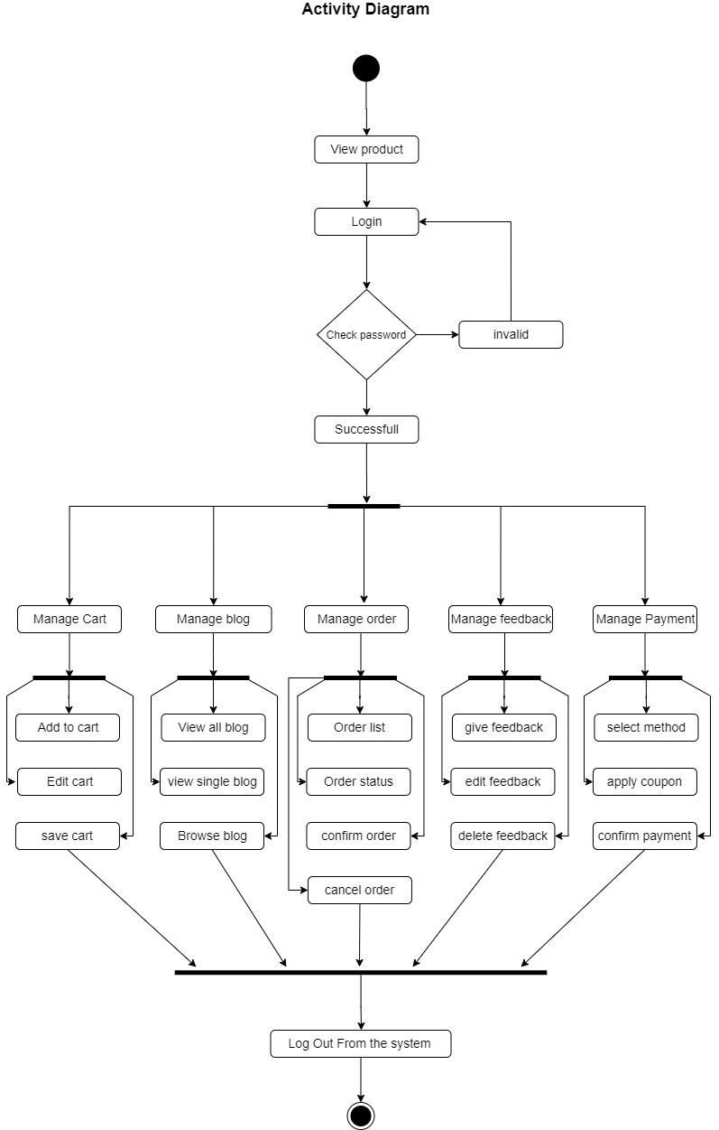

## Class Diagram

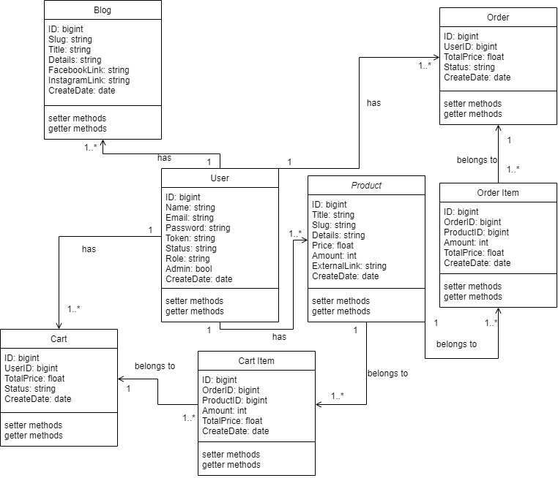

## Entity Relationship Diagram

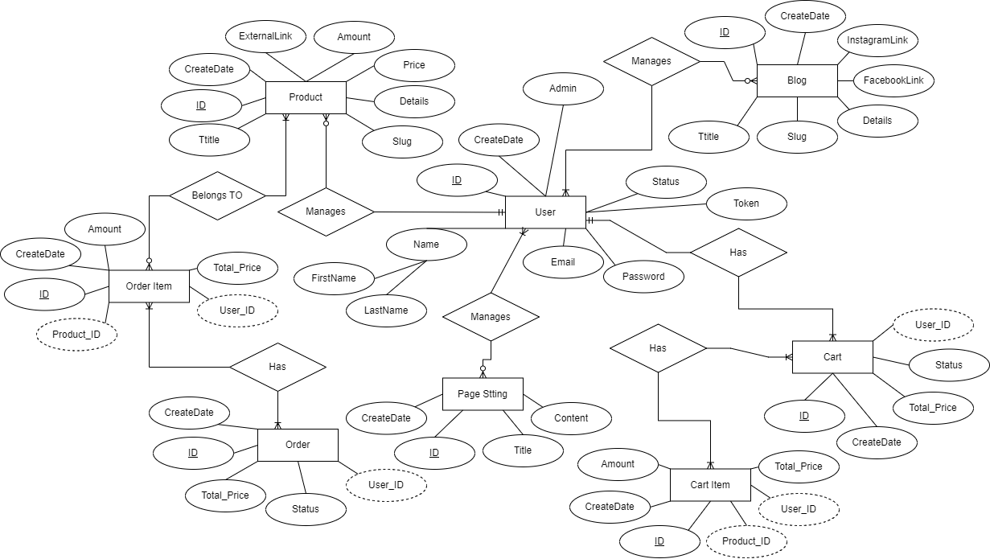

## UI Design Specification

The Figma tool was used to develop the prototypes of this project such as User Interface (UI) and User Experience (UX).

